Factor Analysis

Assignment 5.1

Rebecca Leu

The goal of factor analysis is to find correlated variables that can make up a category of one similar factor. For this example, we are looking at a dataset of participants self-ratings on different personality traits. What we want to do is see which of these traits are correlated and how can we group them into just a few factors for observation and analysis.

The first thing we might complete before beginning our factor analysis on the dataset is to make a correlation plot. The correlation plot will give us a great visual representation of which of these traits correlate negatively and positively with each other. The color scale helps us visually interpret this plot. For example, if we find the darkest red dot on the plot we can trace it back to the traits organized and disorganized. These two traits are literal opposites of each other which is why we get that dark red, or highly negatively correlated results. The dark blue dots just represent where the two terms correlate with each other.

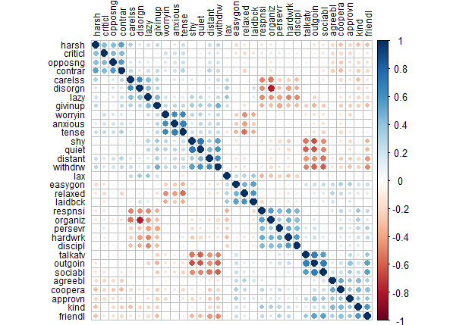

After this we start our factor analysis by first standardizing the variables. This just helps to put all of the variables on the same scale. Standardizing is calculating the mean and standard deviation of a variable. We can first do a factor analysis without rotation where we can look at the maximum likelihood estimation. This will tell us which of the traits can be grouped into each factor. When we look at this output we are looking at the SS or sum of squared loadings number. The factors with values above 1 are noted at the important factors.

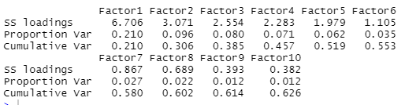

Since we know that the first factor is the most important, we can then compute the eigenvalue of that factor using the factor loadings and estimate this factors proportion of the variance. This is all to say we are trying to see, in this group of factors, how much of these factors accounts for all of the variance in the set.

[1] 0.2095781

Next, we look at the uniqueness of all of the factors for the given variables. We do this to see if all the factors explain a large part of the variance in that variable.

Uniqueness, 0.5844747

Next we can take a look at these factors visually

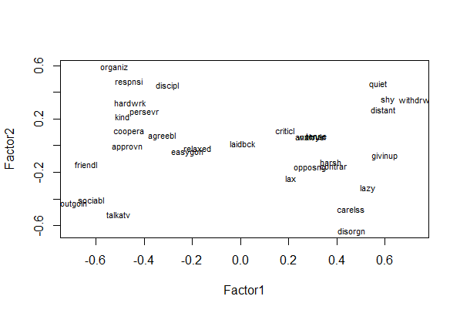

Without rotating the factors this can be hard to make out the different factors. So, we begin rotating the factors to make the interpretation of a factor easier.

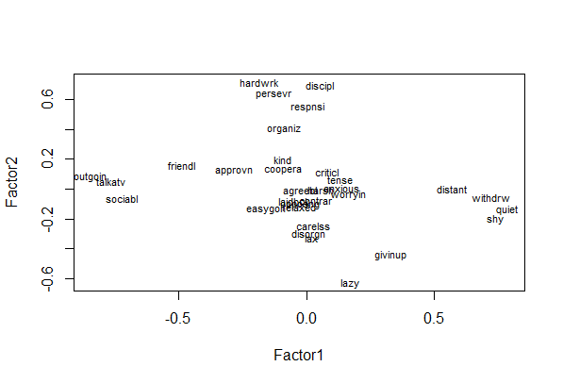



With the rotation we are now able to see now that traits like quiet and talkative are heavy on factor 1 but low on factor 2. From there we could see that factor one could be extraverted or introverted factor.